Mechanical Breadth

The Problem:

During my first visit to the Gordon Fieldhouse I was taken on a walk-through and asked the facilities manager, who also was the project manager of the building, to point out any features of interest, especially anything that was troublesome, was different than originally hoped for but had to be changed because of value engineering, etc. When we got to the competition pool room he immediately pointed out the immense air handling units located near the ceiling. He explained to me that routine maintenance on those pieces of equipment was a ridiculously difficult task because of the locations of the units- large portions of the AHUs jut out over the pool.
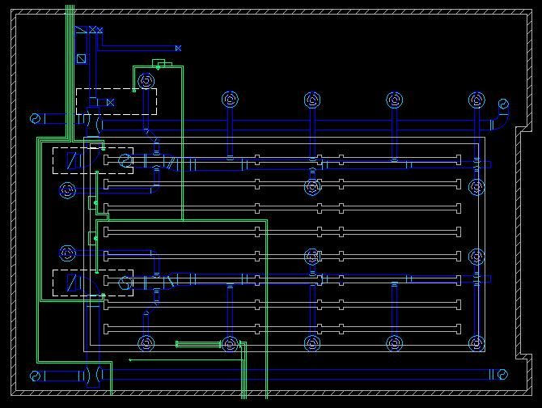

Solution Development:

You can’t just pick up a 22,000cfm supplied Air Handling Unit and place it anywhere. After poring over the Mechanical drawings a few different locations were deemed suitable for relocation, but only one had feasible reducting due to too complex of an existing web of ductwork, beams, conduit, etc. The location was above the space adjacent to the pool (called the pool gallery) and would have to basically centralize air flow distribution, requiring a complex duct system to supply the same type of service the current system does. Other locations that would have been suitable included the fitness center (had reducting not been such a monster of an issue the main drawback of using this space would have been a reduction of usable space for equipment) and above the locker rooms (again, large beams made this a near-impossibility with too much loss from turning the ducts).

The Solution:

Fully prepared to choose the pool gallery solution and back up this choice with a pros and cons list of the other suitable locations to provide a “lesser evil” scenario, I offhandedly made a semi-sarcastic remark to one of my Mechanical Engineering option friends who was helping me to the effect of, “I wish I could just turn them 90 degrees, that way they would be over the deck and not the pool. Problem solved. Breadth complete.” Minutes later I had discovered that not only was the simple solution feasible, it was also the best and had been under my nose the entire time. By rotating each AHU 90 degrees counter clockwise and extending the existing intake ductwork, I could essentially avoid the maintenance issue without major relocation, and only minor reducting, not enough to warrant any resizing.
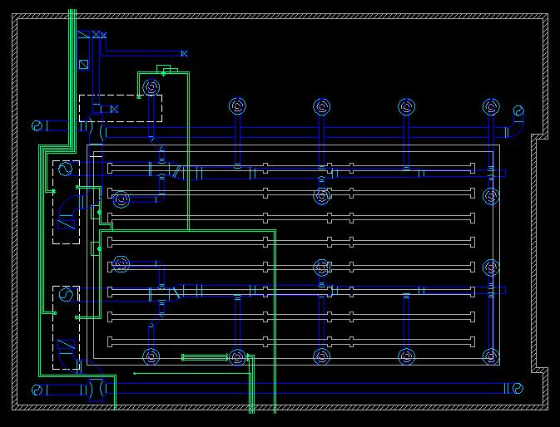
Thinking this solution to be too good to be true, my concern was that the slight relocation would not be admissible from a structural standpoint, but after referencing my structural drawings and performing a quick load calculation my mind was put at ease on this issue, as the rotation would not cause inadmissible loading variations due to a load bearing beam thrice oversized for future growth.

Conclusion:

By rotating the AHUs they now can be serviced without draining the pool to have a flat surface on which to support the genie lift (which is used to maintain the AHUs). All in all, the exigence for the solution to the facilities team’s annoying and time consuming problem could have been avoided with a few clicks of a mouse in the Design Development Stage.

Construction Management Breadth

The Gordon Fieldhouse project came in on cost and on budget, which, unfortunately, is sometimes more of the exception and less of the norm. After researching literally thousands of items of correspondence between the chief Electrical Engineer and various members of the team, it’s clear to me that communication and organization are the two biggest elements that will aid in a successful project delivery.

Now that I have redesigned the lighting of four spaces and completed the electrical coordination of the lighting to the existing system, I will continue in the realm of the hypothetical and discuss how I would proceed as a member of the project team, acting as the electrical engineer. All examples in the following narrative have come from actual documentation of issues and obstacles that came up during the design, development, or construction of the Fieldhouse. My responses suggest ways to avoid these issues or chose alternate ways to solve problems than were actually used by the team during the actual project.

Coordination of Drawings

One of the most common setbacks occur when mistakes are made between members of the team designing in the same ceiling plenum space or the space’s dimensions are changed without discussion. By holding regular team meetings many of these overlaps that can result in days of recalculation, etc. can be avoided. At each meeting it would be advantageous to bring as much information as is possible and appropriate, so if questions are asked the answers are at my fingertips. Preparedness for these meetings would be crucial to their success. Simply “showing up” is not enough; for progress to be made each member of the team needs to know what questions he needs answered by each member to move further in the project. In an industry where time literally is money the meetings should be succinct, efficient and informative. One way to get the team members to “do their homework” is to send out your information in real time or at the end of a set period (for example, every Wednesday send out an update or the drawings you have completed) as you make progress so when the time for the meeting comes around people already know the questions they need to ask and meeting time is not spent on updates.

Documentation of Information
Even though members of the team are termed “professionals” sometimes their actions aren’t. Group dynamics has always been and always will be a challenge for project teams. In situations where information is changing daily and therefore it difficult to keep track of, keeping records in absolutely crucial. Notetaking at meetings, of phone conversations, etc, are not enough. Details make this industry tick and when those details are lost, major setbacks can occur. Recording meetings so there can be no dispute at a later date over information given or decisions reached is an effective solution. Archiving electronic communication regularly with date and time stamps is another way to insure yourself against miscommunication and loss of information. Furthermore, you never know when in the future you may need to call upon a conversation, email, or other type of correspondence to clear yourself, your company, or even save your job. Lawsuits are at an all-time high and an engineer who designs electrical systems which always have a high potential for risk cannot be too careful.

Exhausting Resources

When code and regional ordinances are in play for electrical work (and they almost always are), EE’s can’t afford to be sloppy or lazy. When up against a code issue that only applies marginally to the project, following through with code officials can save large amounts of time in the long run. Understanding that it is someone’s job to interpret code is a vital resource that can also save time when researching a particular aspect of a code. In general, codes change as the industry develops, so staying current is the sign of a honed electrical engineer.

Back-up Plans

Making budget adjustments, variations and cuts are part of the reality of the Architectural Engineering industry. Depending on the client, value engineering is a common way to shave off costs. A good engineer will know the best substitutes for his design or design elements in the event that money must be found from his budget. Utilizing a weighted 3 Brand Spec for fixtures and equipment is one way to ensure a clear establishment of the engineer’s hierarchy regarding desireability each product. A priority list that ranks the elements from most important to least important can dodge lengthy discussions and debates. Understanding the big picture and realizing that flexibility has to come with the job will allow for a smoother running of the overall project.

Conclusion

A myriad of problems can and do arise on site and in the office on major projects. Staying organized and being as communicative as possible make these setbacks manageable. Although every project is different and no set formula can be applied to ensure a flawless delivery, these guidelines offer solutions to true issues that could happen on any project.

